Re-characterizing fire regimes in dry forests: why severity can be misleading

Brandon M. Collins1, 2*, Jens T. Stevens3, Jay D. Miller4, Scott L. Stephens3, Peter M. Brown5, Malcolm North1,6, Hugh Safford 7,8

1USDA Forest Service, Pacific Southwest Research Station, Davis, CA, 95618, USA

2Center for Fire Research and Outreach, University of California, Berkeley, CA, 94720 USA

3Ecosystem Sciences Division, Department of Environmental Science, Policy, and Management, University of California, Berkeley, CA, 94720 USA

4USDA Forest Service, Pacific Southwest Region, Fire and Aviation Management, McClellan, CA 95652, USA.

5Rocky Mountain Tree-Ring Research, 2901 Moore Lane, Ft Collins, CO 80526, USA

6Department of Plant Sciences, University of California, Davis, CA 95616, USA

7USDA Forest Service, Pacific Southwest Region, Vallejo, CA 94592, USA.

8Department of Environmental Science and Policy, University of California, Davis, CA 95616, USA

*Author to whom correspondence should be addressed: e-mail: bcollins@berkeley.edu

**Abstract**

We.

**Introduction**

Departure in disturbance patterns from more natural conditions is often the basis for contemporary ecosystem restoration programs (Swetnam et al. 1999, Safford et al. 2012). Assessing the degree of departure requires fairly detailed descriptions of current (departed) and reference (natural) disturbance patterns. With regard to fire, remote sensing products allow for robust characterizations of current extents and severity patterns (e.g., Miller and Thode 2007), but similar detail is often lacking for reference conditions. As a result, we often rely on coarser scale characterizations of fire patterns under reference conditions. Fire regime type (i.e., low, mixed, and high severity) is a readily used example for broadly characterizing fire occurrence and effects prior to 20th century fire suppression and exclusion policies (Agee 1998, Schoennagel et al. 2004). Each fire regime type is associated with distinct patterns of fire severity, which can be compared to current fire severity patterns to assess departure (e.g., FRCC 2010).

Dendroecological reconstructions have provided a majority of the information from which historical disturbance regimes have been inferred (Fulé et al. 1997, Swetnam et al. 1999, Taylor 2004). There are two predominant phenomena by which past disturbance events can be inferred from tree rings, through direct, non-lethal cambial injury recorded in tree ring series (e.g., fire scars) and through the formation of distinct post-disturbance cohorts. Conventionally, fire scar-based reconstructions were used in forest types historically associated with low- to moderate-intensity surface fires , while stand age reconstructions were used in forest types associated with high intensity, crown fires (Romme 1982). More recent studies, primarily from the former forest types, have coupled fire scar collections with extensive tree age structure sampling (Beaty and Taylor 2007, Brown et al. 2008). These studies have allowed for the indirect inference to fire severity through identification of post-fire cohorts. However, many dry conifer forests have several age classes within a single stand, which make identification of distinct post-fire cohorts difficult (Stevens et al. 2016).

Dendroecological studies do well at characterizing the two extremes of historical fire regimes in forests, i.e., frequent, low-intensity, non-lethal fires and infrequent, high-intensity, lethal fires. Example forest types with these respective fire regimes include southwestern U.S. ponderosa pine (*Pinus ponderosa*) and Rocky Mountain lodgepole pine (*Pinus contorta*) (Schoennagel et al. 2004). The problem is the majority of dry forest types have fire regimes somewhere in between these two extremes, leading to the development of the “mixed-severity” fire regime (Perry et al. 2011, Hessburg et al. 2016). Hessburg et al. (2016) define mixed-severity fires as fires “where 20–70% of the dominant tree basal area or canopy cover of a given patch of forest is killed by any single instance of fire”. Forest types with characteristically mixed-severity fire regimes historically had structures that were maintained by non-lethal surface fire (i.e., large, widely spaced, early-seral trees) intermixed with discrete vegetation patches (i.e., shrubs, dense conifer stands) created by “stand-replacing” fire, either due to active crown fire or heat-killing from heavy surface fuels (Agee 1998, Hessburg et al. 2016). This is corroborated by the insightful observations of fire in un-harvested Sierra Nevada pine-mixed-conifer forests made by Show and Kotok (1924):

“[n]o large fires occur without a certain amount of heat-killing…This loss, it should be noted, represents the complete or nearly complete wiping out of small patches of the stand rather than a uniformly distributed loss over the entire area”.

The occurrence of both surface and crown fire in the same forest type historically resulted in highly complex vegetation – fire interactions, (Perry et al. 2011). This complexity along with the wide amplitude in fire effects across a single burn event (often described as 20-70% overstory mortality - Agee 1993, 1998) has led to considerable uncertainty identifying the historical range of variation for forests described as having “mixed-severity” fire regime (Perry et al. 2011). There is strong disagreement in inferring historical (i.e., natural) proportions and patch sizes of stand-replacing fire effects (Williams and Baker 2012, Fulé et al. 2013, Odion et al. 2014, Stevens et al. 2016). As a result, current departure in fire patterns for these forest types is also contested (Mallek et al. 2013, Odion et al. 2014). This debate is not simply academic; it has strong implications for forest restoration throughout the western U. S. If contemporary patterns of stand-replacing fire effects in these forests are within the range of historical variability, large-scale restoration programs (e.g., USDA-FS 2012) may be lacking a sound ecological underpinning.

One of the primary shortcomings of the use of the term “mixed-severity” is that it is increasingly used to describe all forest fires where between 20% and 70% of the fire area is mapped as high-severity (Odion et al. 2014). This classification scheme ignores important information regarding the size and shape of high-severity patches that is highly relevant to the processes that drive tree regeneration in mixed-conifer forests. We propose a new, more ecologically relevant approach for describing patterns of fire effects in these forest types. Although accurate assessments of departure are hampered by the incomplete nature of historical data, our approach will allow for more meaningful characterizations of contemporary fire patterns.

**Problems with using “percent high severity” to describe fire regimes**

Despite having widely used definitions for binning fire regimes based on cumulative overstory mortality levels (<20%, 20-70%, >70%; Agee 1993), there is considerable ambiguity in the scale at which these mortality thresholds should be applied. It is possible to have relatively low to moderate overall proportions of stand-replacing effects within individual fires result in different spatial patterns of mortality. At fine spatial scales (e.g., individual trees or small groups of trees) most fires in dry forests will have a portion of burned area that experiences stand-replacing fire (Brown et al. 2008). Even “low-severity” fires will occasionally kill adult canopy trees; this is an important part of how low-severity fires maintain resilience. However a fire with 20% overstory mortality that is widely scattered as individual dead trees within the burned area is ecologically distinct from a fire with 20% overstory mortality that is aggregated in a few larger patches. This suggests that these thresholds are more suited for coarser spatial scale assessments, such as summarizing the percentage of individual fires that is mapped as discrete stand-replacing patches, or possibly multiple fires over time across a landscape (Agee 1998).

Most evaluations of modern burn severity rely on classifications of Landsat pixels by the change in vegetation reflectivity before and after fires (e.g. RdNBR; Miller and Thode 2007). Using these satellite data calibrated to field plots, it is possible to assign categorical classifications of low, moderate and high severity fire *at the 30-m pixel scale*, e.g. based on mean RdNBR values associated with <20%, 20-70% and >70% overstory mortality, respectively (Miller et al. 2009). Although Hessburg et al. (2016) define “mixed-severity” fires as having 20-70% mortality within a given burned area, fires where a majority of the area is mapped as moderate severity are exceedingly rare (Belote 2015). Nonetheless, a fire with >50% moderate severity and little to no high severity could certainly be termed “mixed-severity”, the distinction is that most of the mortality is occurring at a sub-30m pixel scale.

A more frequently observed pattern is that “mixed-severity” fires have some substantial (>20%) proportion of their area mapped as contiguous high-severity patches, and other areas mapped as contiguous low or moderate severity patches. Even within areas mapped high-severity using an RdNBR value associated with >70% overstory mortality, mortality is most often 100% when greater than 30m in from the edge of a contiguous patch (Miller and Quayle 2015), so patches classified as “high-severity” generally are truly stand-replacing. However, even in boreal and subalpine forest types where crown-fire is adaptive, contemporary fires very rarely have more than 70% of their area mapped as “high-severity” (Belote 2015, Harvey et al. 2016).

We therefore argue that the defining characteristic of high-severity fire regimes is not whether >70% of the fire was mapped as high-severity, but rather it is the size and shape of contiguous stand-replacing patches. To illustrate this, we examined two recent fires in the northern Sierra Nevada to illustrate this point (Figure 1). The 2012 Chips Fire in the Plumas National Forest burned with a very modest overall proportion of stand-replacing fire (22%). Note, we used the “high-severity” threshold described by Miller and Thode (2007), which corresponds with >95% basal area mortality (Lydersen et al. 2016). This proportion of stand-replacing fire was very similar to a fire that of the 2008 Cub Complex (20%), which occurred 10km northwest of the Chips Fire. The patterns of stand-replacing effects, however, were distinct. Forty-three percent of the stand-replacing area in the Chips Fire was aggregated in contiguous patches that were larger than 250 ha, while for the Cub Complex only 24 % was in the >250 ha class (Figure 1). Furthermore, stand-replacing area was relatively evenly distributed among patch size classes for the Cub Complex, but heavily skewed for the Chips Fire (Figure 1).

The potential impact of these different distributions of stand-replacing patch area on post-fire vegetation dynamics is significant. Large, contiguous and roundly-shaped patches of tree mortality have much more “core” area (see Cansler and McKenzie 2014), while smaller patches have greater proportions of edge, and lesser distances-to-patch edge. For the Chips Fire 33% of the stand-replacing patch area is >120 m from patch edges, compared to 17% for the Cub Complex (Figure S1). This contrast is ecologically relevant because the dominant tree species in this forest type (i.e., Sierra Nevada mixed-conifer) lack direct mechanisms for establishment following stand-replacing fire (e.g., vegetative re-sprouting, seed stored in serotinous cones). The significance of the 120 m threshold is that it exceeds the likely distance of seed dispersal for even the tallest conifers in this area (McDonald 1980). This means that a considerable amount of the stand-replacing area in the Chips Fire will likely be void of natural conifer regeneration for an extended period of time (Collins and Roller 2013). While these different patterns may be related the disparity in overall fire sizes (Chips: 30,898 ha; Cub: 7940 ha), they emphasize the importance in not only examining overall proportions of stand-replacing effects, but at patch sizes and the distribution of area among patch size classes.

**Alternate characterization of fire regimes**

Building on the ideas discussed around the two contrasted fires above, we developed a mathematical model to describe the relationship between stand-replacing patch area and distance from edge, which is the most relevant metric of fire severity. Rather than simply plotting distributions of stand-replacing area by patch size class, which would result in only one class for each configuration, we sought a more process-based characterization of these very different configurations. Given that in dry forests one of the primary factors limiting tree regeneration following a stand-replacing disturbance is seed dispersal, we focused on distance-to-patch-edge as the key process variable. The term “core patch area” has been used to describe the amount of stand-replacing fire that remains greater than a given distance in from the patch edge (citations?). However, core patch area depends on the distance threshold used. We extend this concept to describe the entire shape of the relationship between 1) the proportion of original stand-replacing area, and 2) the internal buffer distance applied to all mapped high-severity polygons (Figure 2). The proportion of original stand-replacing area remaining within a given internal buffer distance is necessarily bounded between 1 and 0 inclusive, equaling 1 when the internal buffer distance is zero (as all the original patch area remains), and equaling 0 when the internal buffer distance is equal to the maximum distance to edge within the largest patch. This relationship can be approximated for multiple irregularly shaped patches by a modified logistic function:

(Eq. 1)

where is the proportion of the original stand-replacing area, is the internal buffer distance, and is a free parameter that describes the shape of the relationship which we call the *decay coefficient*. Larger values of describe to more rapidly decaying proportional patch area, while smaller values of *q* describe more slowly decaying proportional patch area.

To illustrate this relationship, we generated four hypothetical scenarios of stand-replacing patches with identical areas and proportions of the landscape (Figure 2A-D). Each scenario had 1000 ha of area in stand-replacing patches, but scenario A had 1024 circular patches of 0.977 ha each, scenario B had 100 patches of 10 ha each, scenario C had 9 patches of 111 ha each, and scenario D had 1 patch of 1000 ha. The fitted values of *q* were 0.219, 0.068, 0.002, and 0.0006 for scenarios A-D, respectively. This translates to predictions of <0.001% of original stand replacing area greater than 120m from the patch edge in scenarios A and B, 57.5% of original stand replacing area greater than 120m from the patch edge in scenario C, and 84.7% of original stand replacing area greater than 120m from the patch edge in scenario C. The decay coefficient *q* does not capture the complete loss of high-severity area with a large enough distance because the modified logistic function does not go to zero, but it is a very good approximation of the rate of loss of high-severity area with increasing distance from edge, which is the value of ecological importance. Further, the decay coefficient appears to distinguish among the configurations with intermediate sized patches (Figure 2B and 2C), with corresponding intermediate q values (Figure 2E). The interpretation of these different distributions is that flatter curves depict greater proportions of stand-replacing area at larger distances from “green” forest edge.

We tested the application of this approach with two actual wildfires. Because of the potential influence of total fire size on stand-replacing proportion and patch sizes (Cansler and McKenzie 2014) we chose a different pair of fires to compare stand-replacing area at different distances to patch edge. These fires, 1987 East Fire and 2008 Caribou Fire, occurred in the Klamath region of northwestern California, and were similar in total size and proportion of stand-replacing fire (~5000 ha, 20% - Figure 3A). Unlike our hypothetical fires (Figure 2) both of these fires exhibited a range of patch sizes, so it was uncertain how well the univariate decay function would capture actual patterns of stand-replacing patches. Plots of both observed and fitted stand-replacing proportions as a function of interior distance were quite consistent (Figure 3B), suggesting this decay function could be applied to actual fires. The two example fires had noticeably different decay curves, with the East Fire having a much longer and flatter shape (Figure 3B). This shape reflects the disproportionate amount of area in large stand-replacing patches observed for the East Fire relative to the Caribou Fire. In the absence of post-fire vegetation management these two fires would be expected to have noticeably different landscape vegetation patterns, i.e., more coarse-grained or homogenous patterns for the East Fire. Interactions with subsequent disturbances, namely fire, would also be expected to differ as well (Coppoletta et al. 2016).

**Considerations with this approach**

To further investigate the applicability of this new metric, we applied the decay coefficient function to 436 fires that burned in California between 1984 and 2015. We selected fires >100 ha that were classified as predominantly occurring on forestland, regardless of the managing agency. The resulting values of *q* were approximately normally distributed after a log transformation (Fig. S2), which appears to clearly distinguish the few select fires that have extremely small decay coefficients and thus have a very high proportion of their high-severity area far from the nearest patch edge. Not surprisingly, fires that are larger and have a higher proportion of high-severity fire tend to have smaller decay coefficients (Fig. S3, S4 respectively). However, for any given fire size or percent severity, there are still a fairly wide range of potential *q* values, which illustrates profound ecological differences among “mixed-severity” fires that might otherwise be considered very similar if percent high severity were used as the relevant variable. Thus, *q* may be a reasonable integration of both these variables that, but it also contains additional information that is highly relevant to quantifying forest resilience.

* [Could give the example here of the Rim fire and some other fire that had similar percent high severity but much lower q; Rim had ~35% high severity but its log(q) was ~6.5 (see Fig. S4), which is the lowest of any fire having about that percent high severity].
* Maybe contrasting King fire (high core area, moderate q) and Moonlight (opposite)
* Potential to label “good” and “bad” fires, when in fact there can be attributes of both in a single event.
* We could foreshadow that having a single relevant metric like this could enable interesting comparisons of multiple fires across space and time, which we’re planning to do in the next paper.

**Implications for forest restoration**

Despite the limitations discussed previously our approach of plotting stand-replacing proportions as a function of interior distance offers a relatively simple way to capture complex patterns of fire effects. The decay curves and associated parameter *q* can be calculated for individual fires and summarized for multiple fires over a given area. This allow for quantative comparisons between individual fires and among regions. Furthermore, patterns of individual fires or aggregations of fires can be assessed relative to desired land management outcomes. We may never know the appropriate distribution for a given forest type and/or that was likely not static over time

While we focus on the “mixed-severity” class, our approach may have applications across the spectrum of fire regime types. All of the example fire (hypothetical and actual) could be considered mixed-severity.

Subclasses within mixed severity (Hessburg et al. 2016).

**References**

Agee, J. K. 1993. Fire ecology of Pacific Northwest forests. Island Press, Washington D.C., USA.

Agee, J. K. 1998. The landscape ecology of Western forest fire regimes. Northwest Science 72:24-34.

Beaty, R. M., and A. H. Taylor. 2007. Fire disturbance and forest structure in old-growth mixed conifer forests in the northern Sierra Nevada, California. Journal of Vegetation Science 18:879-890.

Brown, P. M., C. L. Wienk, and A. J. Symstad. 2008. Fire and forest history at Mount Rushmore. Ecological Applications 18:1984-1999.

Cansler, C. A., and D. McKenzie. 2014. Climate, fire size, and biophysical setting control fire severity and spatial pattern in the northern Cascade Range, USA. Ecological Applications 24:1037-1056.

Collins, B. M., and G. B. Roller. 2013. Early forest dynamics in stand-replacing fire patches in the northern Sierra Nevada, California, USA. Landscape Ecology 28:1801-1813.

Coppoletta, M., K. E. Merriam, and B. M. Collins. 2016. Post-fire vegetation and fuel development influences fire severity patterns in reburns. Ecological Applications 26:686-699.

FRCC. 2010. Interagency Fire Regime Condition Class guidebook, version 3.0. National Interagency Fuels, Fire, and Technology Transfer.

Fulé, P. Z., W. W. Covington, and M. M. Moore. 1997. Determining reference conditions for ecosystem management of southwestern ponderosa pine forests. Ecological Applications 7:895-908.

Fulé, P. Z., T. W. Swetnam, P. M. Brown, D. A. Falk, D. L. Peterson, C. D. Allen, G. H. Aplet, M. A. Battaglia, D. Binkley, C. Farris, R. E. Keane, E. Q. Margolis, H. Grissino-Mayer, C. Miller, C. H. Sieg, C. Skinner, S. L. Stephens, and A. Taylor. 2013. Unsupported inferences of high-severity fire in historical dry forests of the western United States: response to Williams and Baker. Global Ecology and Biogeography:n/a-n/a.

Hessburg, P. F., T. A. Spies, D. A. Perry, C. N. Skinner, A. H. Taylor, P. M. Brown, S. L. Stephens, A. J. Larson, D. J. Churchill, N. A. Povak, P. H. Singleton, B. McComb, W. J. Zielinski, B. M. Collins, R. B. Salter, J. J. Keane, J. F. Franklin, and G. Riegel. 2016. Tamm Review: Management of mixed-severity fire regime forests in Oregon, Washington, and Northern California. Forest Ecology and Management 366:221-250.

Lydersen, J. M., B. M. Collins, J. D. Miller, D. L. Fry, and S. L. Stephens. 2016. Relating fire-caused change in forest structure to remotely sensed estimates of fire severity. Fire Ecology 12.

Mallek, C., H. Safford, J. Viers, and J. Miller. 2013. Modern departures in fire severity and area vary by forest type, Sierra Nevada and southern Cascades, California, USA. Ecosphere 4:153.

McDonald, P. M. 1980. Seed dissemination in small clearcuttings in north-central California. General Technical Report PSW-150, U.S. Department of Agriculture, Forest Service, Pacific Southwest Forest and Range Experiment Station, Berkeley, CA, USA.

Miller, J. D., and A. E. Thode. 2007. Quantifying burn severity in a heterogeneous landscape with a relative version of the delta Normalized Burn Ratio (dNBR). Remote Sensing of Environment 109:66-80.

Odion, D. C., C. T. Hanson, A. Arsenault, W. L. Baker, D. A. DellaSala, R. L. Hutto, W. Klenner, M. A. Moritz, R. L. Sherriff, T. T. Veblen, and M. A. Williams. 2014. Examining historical and current mixed-severity fire regimes in ponderosa pine and mixed-conifer forests of western North America. Plos One 9:e87852.

Perry, D. A., P. F. Hessburg, C. N. Skinner, T. A. Spies, S. L. Stephens, A. H. Taylor, J. F. Franklin, B. McComb, and G. Riegel. 2011. The ecology of mixed severity fire regimes in Washington, Oregon, and Northern California. Forest Ecology and Management 262:703-717.

Romme, W. H. 1982. Fire and landscape diversity in subalpine forests of Yellowstone National Park. Ecological Monographs 52:199-221.

Safford, H. D., G. D. Hayward, N. E. Heller, and J. A. Wiens. 2012. Historical ecology, climate change, and resource management: can the past still inform the future? Pages 46-62 *in* J. A. Wiens, G. D. Hayward, H. D. Safford, and C. M. Giffen, editors. Historical environmental variation in conservation and natural resource management, first edition John Wiley & Sons.

Schoennagel, T., T. T. Veblen, and W. H. Romme. 2004. The interaction of fire, fuels, and climate across Rocky Mountain forests. Bioscience 54:661-676.

Show, S. B., and E. I. Kotok. 1924. The role of fire in the California pine forests.Bulletin No. 1294, U. S. Department of Agriculture, Government Printing Office, Washington, DC, USA.

Stevens, J. T., H. D. Safford, M. P. North, J. S. Fried, A. N. Gray, P. M. Brown, C. R. Dolanc, S. Z. Dobrowski, D. A. Falk, C. A. Farris, J. F. Franklin, P. Z. Fulé, R. K. Hagmann, E. E. Knapp, J. D. Miller, D. F. Smith, T. W. Swetnam, and A. H. Taylor. 2016. Average Stand Age from Forest Inventory Plots Does Not Describe Historical Fire Regimes in Ponderosa Pine and Mixed-Conifer Forests of Western North America. Plos One 11:e0147688.

Swetnam, T. W., C. D. Allen, and J. L. Betancourt. 1999. Applied historical ecology: using the past to manage for the future. Ecological Applications 9:1189-1206.

Taylor, A. H. 2004. Identifying forest reference conditions on early cut-over lands, Lake Tahoe Basin, USA. Ecological Applications 14:1903-1920.

USDA-FS. 2012. Increasing the pace of restoration and job creation on our National Forests.Published Report, U.S. Department of Agriculture, Forest Service.

Williams, M. A., and W. L. Baker. 2012. Comparison of the higher-severity fire regime in historical (A.D. 1800s) and modern (A.D. 1984-2009) montane forests across 624,156 ha of the Colorado Front Range. Ecosystems 15:832-847.

Figure captions

Figure 1. Contrasting spatial patterns of fires that burned with “mixed” severity in the Sierra Nevada, USA (top). Fire severity classes are based on the relative differenced normalized burn ratio (RdNBR) using threshold values from Miller and Thode (2007). RdNBR histograms of all 30 m pixels within fire perimeters (middle) are colored by the same fire severity class thresholds, with total percentages for each class reported above. Distributions of both proportional stand-replacing patch area and number of stand-replacing patches (bottom) pertain to the “high” severity class alone. Patches were delineated using the same methodology described in Collins and Stephens (2010). The shaded bands in these distributions indicate the mean proportion of total patch area +/- one standard deviation. Means and standard deviations were calculated using all non-zero patch size class proportions.

Figure 2. Four hypothetical stand-replacing patch configurations for the same total fire area (3600 ha) and stand-replacing proportion (28%). Patch sizes were ~1 ha (a), 10 ha (b), ~100 ha (c) and 1000 ha (d). Panel (e) illustrates how stand-replacing area in these different configurations is distributed as a function of distance-to-patch-edge (i.e., moving further towards the interior of patches). Plots for the different configuration were fitted to the modified logistic function in Eq. 1. The parameter *q* is reported for each configuration.

Figure 3. Stand-replacing area for two example wildfires that occurred in the Klamath region, northwestern California, USA. Both fires have similar total area (4643 ha and 5319 ha) and stand-replacing proportions (20%), but different patterns of stand-replacing area. These different patterns are captured by the plots showing how stand-replacing area is distributed as a function of distance-to-patch-edge. The numbers reported are the *q* parameter for each fitted line (described in Figure 2).

Figure 1.

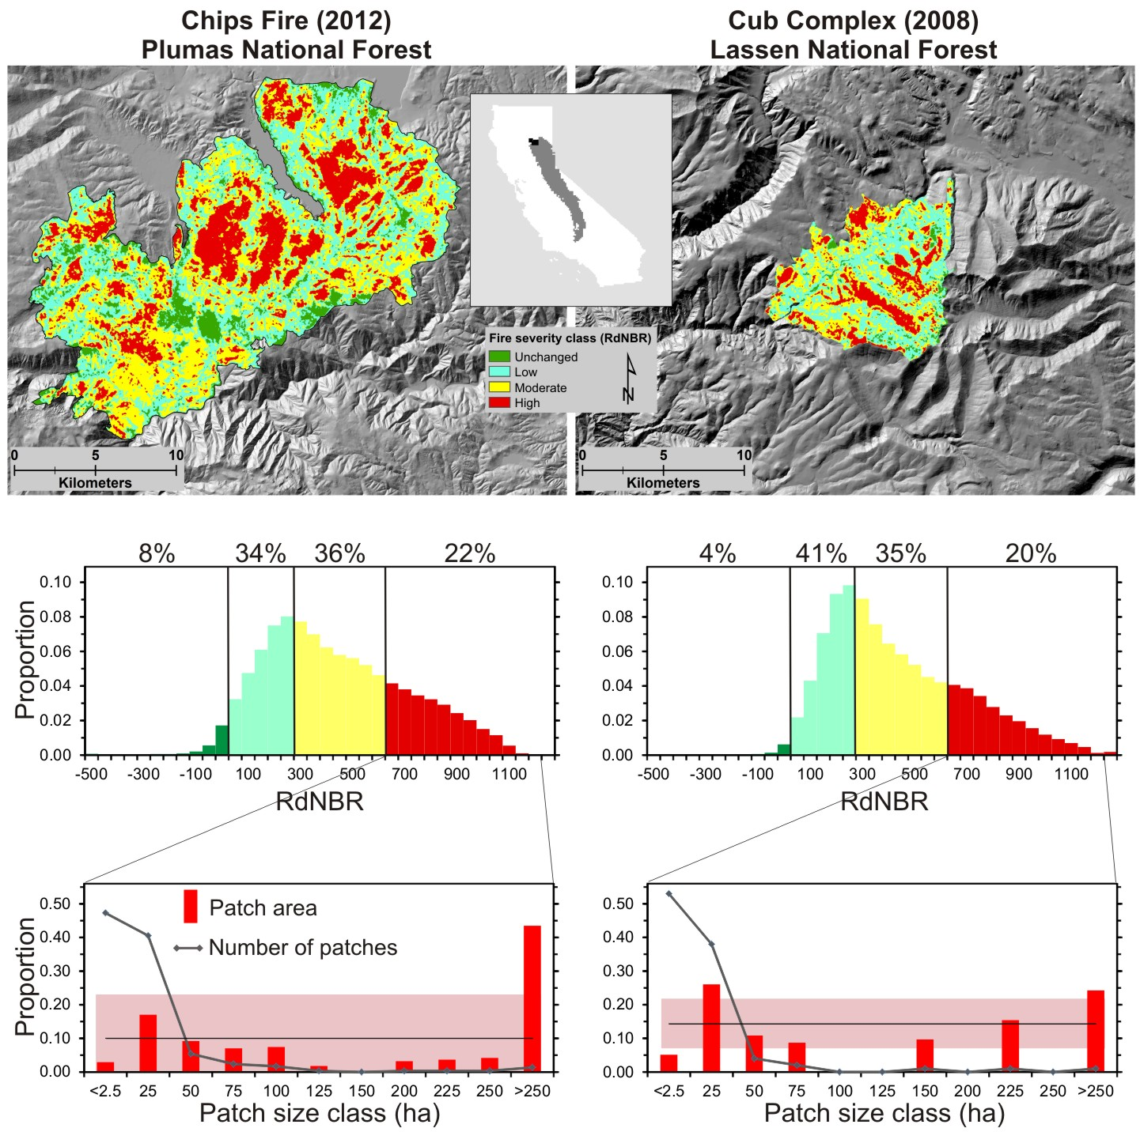

Figure 2. [Jens will eventually label and replace y axis in panel E with “proportion of original stand-replacing area” to be consistent throughout.]



Figure 3



Figure S1. Proportion of stand-replacing patch area within different distance-to-patch-edge classes. Proportions were inferred from the number of regular grid points (250m by 250m) that fell within the different distance-to-edge classes.

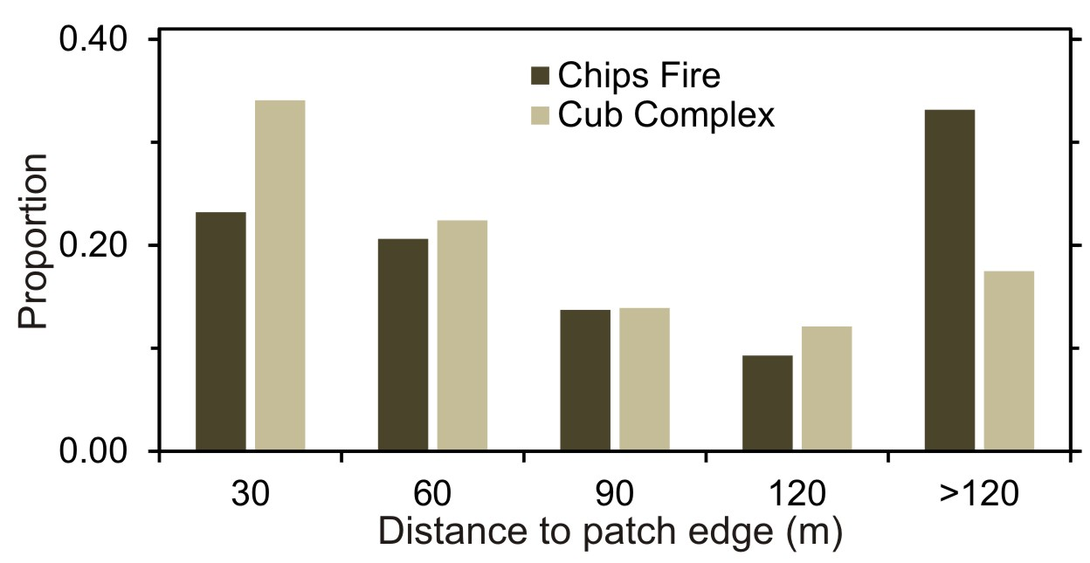

Figure S2. Distribution of the decay coefficient estimated for 436 fires in California between 1984 and 2015. The four colored lines correspond to the colors and patch configurations in Fig. 2. Smaller values of log(*q*) indicate fires with much of their high-severity area far from the patch edge. Exact values for any given distance to patch edge can be estimated using Eq. 1.



Figure S3: The log of the decay coefficient (*q*) as a function of the log of the fire size in ha, for 432 fires in California from 1984-2015. Larger fires are associated with smaller *q* values, but there is considerable variation in q for any given fire size class. The colored lines represent the different hypothetical patch configurations in Fig. 2.



Figure S4: The log of the decay coefficient (*q*) as a function of the percent mapped high-severity fire, for 432 fires in California from 1984-2015. Fires with a larger percentage of high-severity fire are associated with smaller *q* values, but there is considerable variation in q for any given fire severity. The colored lines represent the different hypothetical patch configurations in Fig. 2.

